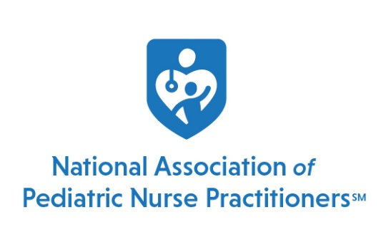

Special Interest Group Annual Budget

Each year, all SIGs are required to submit a budget to the National Office by July 29. Once the budget is approved by the Member at Large, collected funds will be distributed quarterly following receipt of financial reports by the National Office.
Budget for Fiscal Year
SIG name: PEC SIG
Chairperson: Nicole Koepke and Hilary Baxter
Submitted By: Cassandra Newell
PROJECTED INCOME:
ITEM | AMOUNT | DOCUMENTATION
Dues | $6,933.04 | Carried forward from previous year
Grants
Fund Raising
Other:
TOTAL PROJECTED INCOME | $6,933.04
PROJECTED EXPENSES:
ITEM | EXPENSE | DOCUMENTATION
Administrative Cost | $3,466.52 | 50% of SIG membership dues
Conference Expenses | $400 | Travel stipend for 2 PEC SIG instructors to support the 2021 Suturing Course at NAPNAP's Fall Symposium in Orlando, Florida
Other Expense | $1,470 | 147 active PEC SIG members to receive a digital $10 Starbucks gift card to promote and encourage members to listen to the PEC SIG's FousED podcast on TeamPeds Talks with a cup of coffee or tea on us!
Other Expense | $250 | NAPNAP Foundation donation for National Conference 2022
 | $250 | NAPNAP’s Virtual Silent Auction 9/28/21-10/2/21
TOTAL EXPENSES | $ 5,836.52 | (Balanced budget – annual income and annual expenses)

*Note: Only if funds allow for expense

